Loading Arduino with USB
1 Connect Arduino to Computer
If your computer needs drivers direct it to the folder named “drivers”

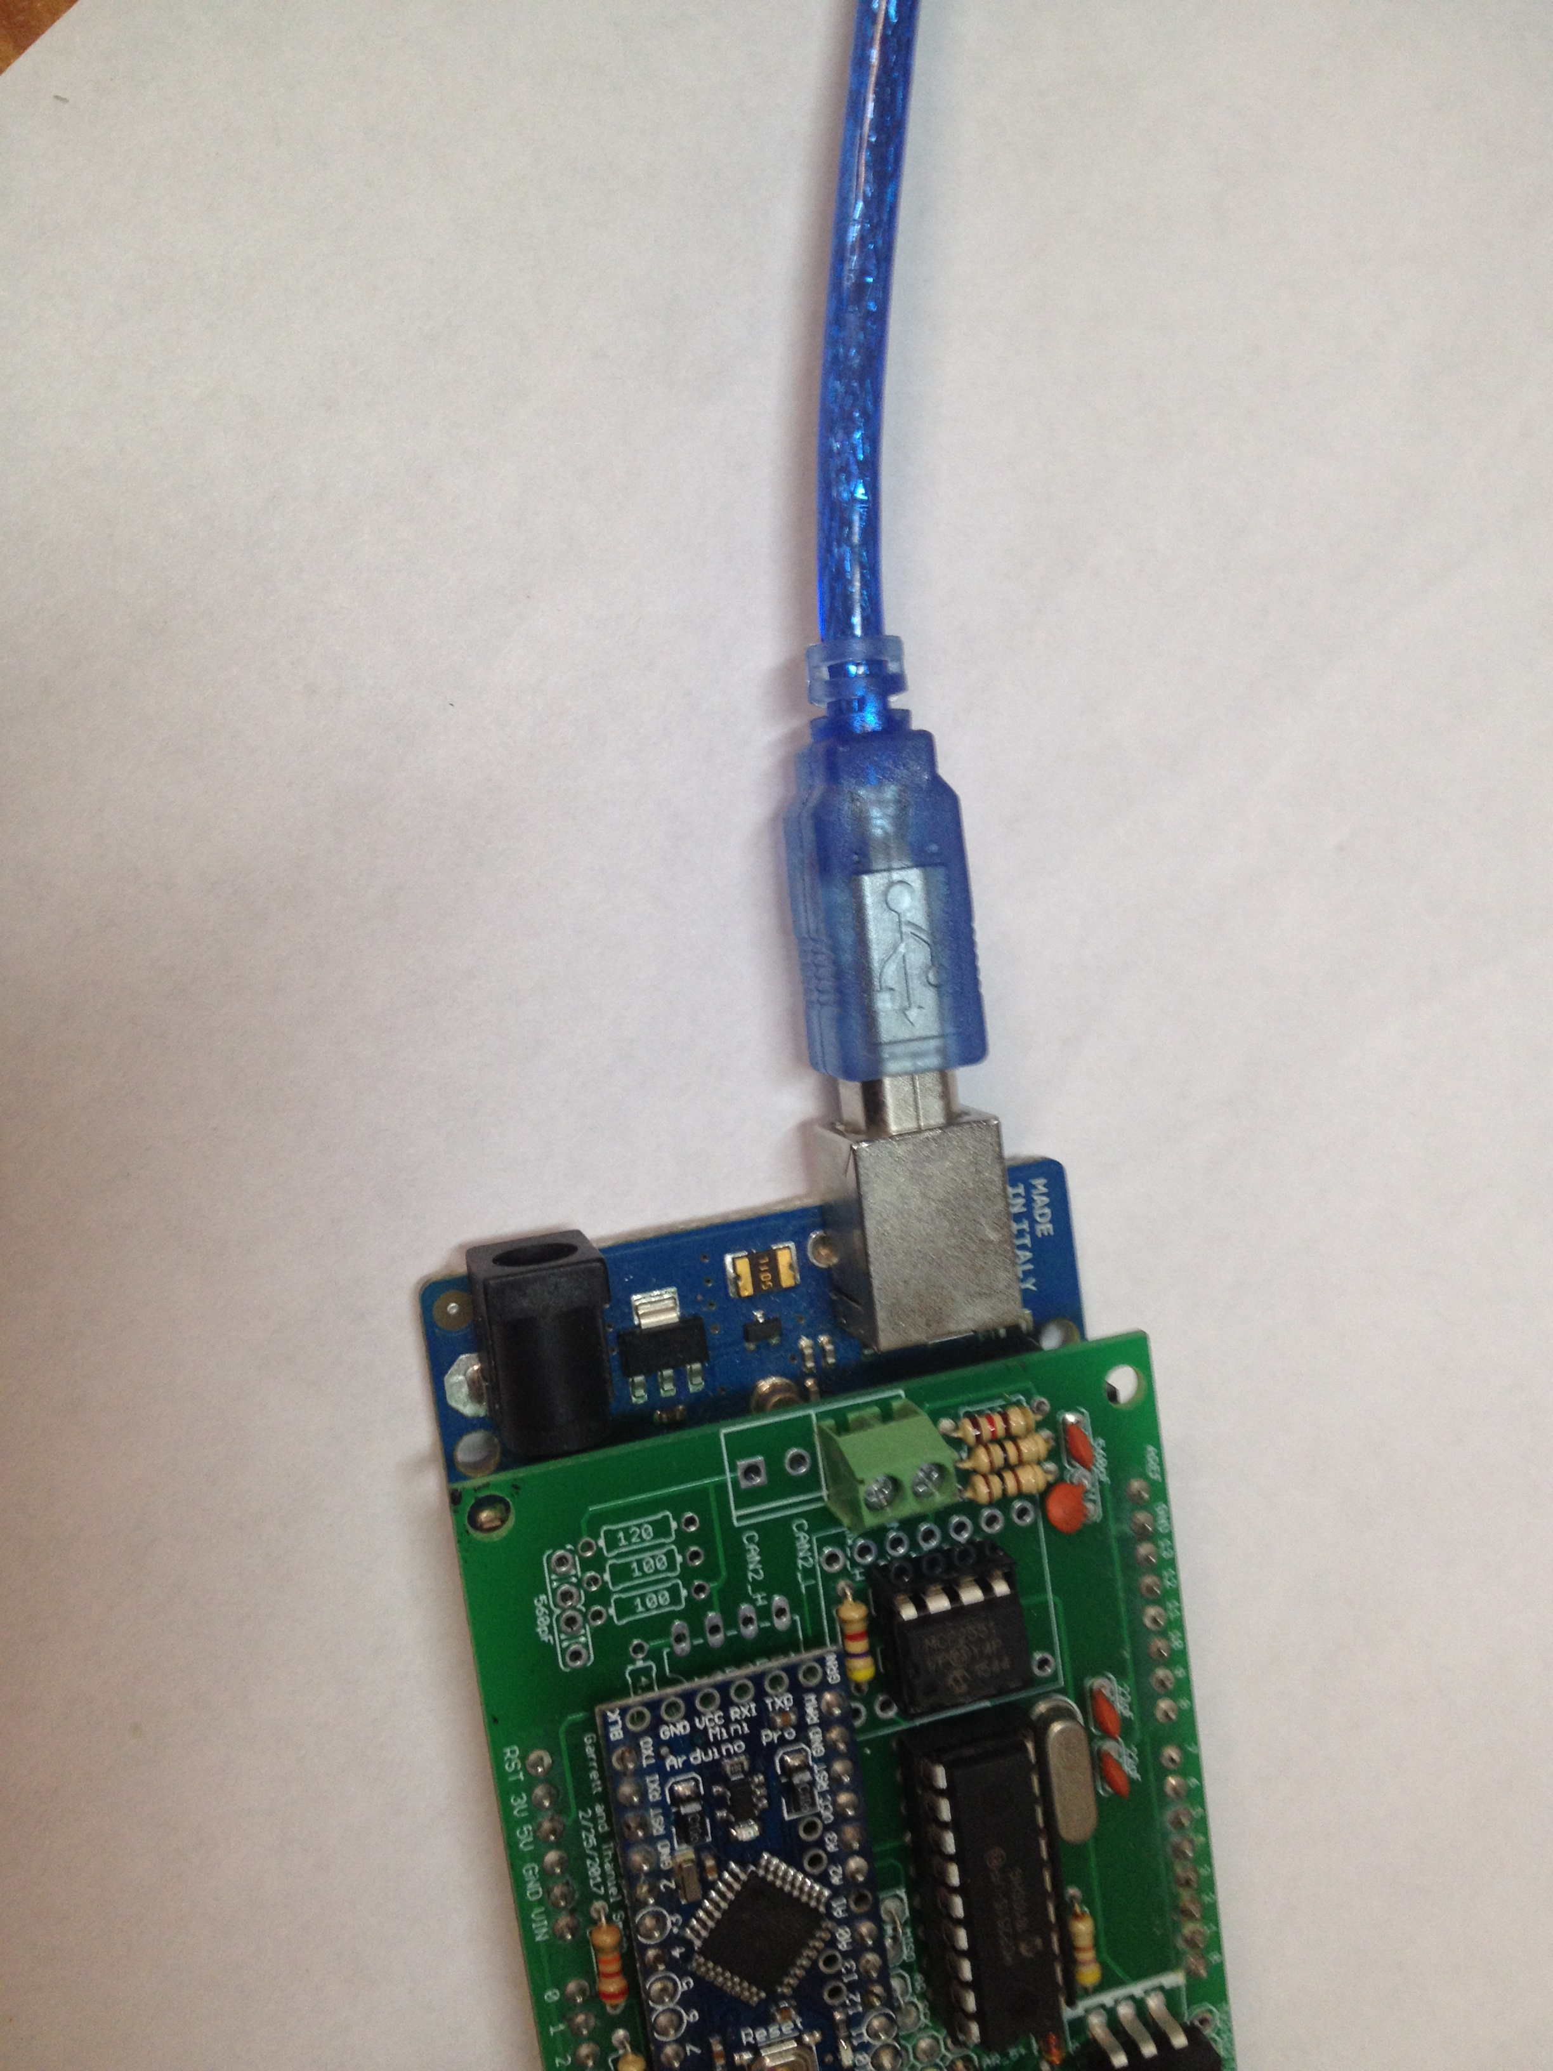

2 open Xloader.exe in the Xloader folder
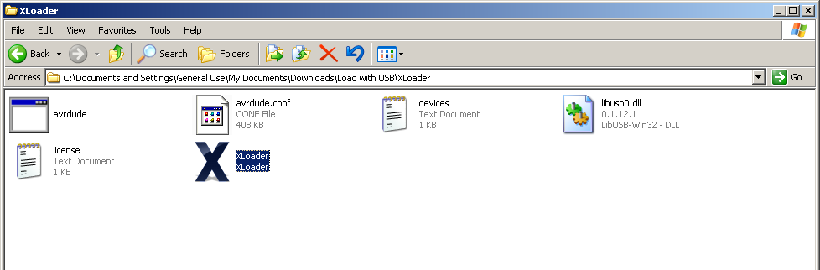
3 select the button next to hex file and select the program to load
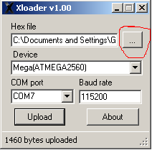
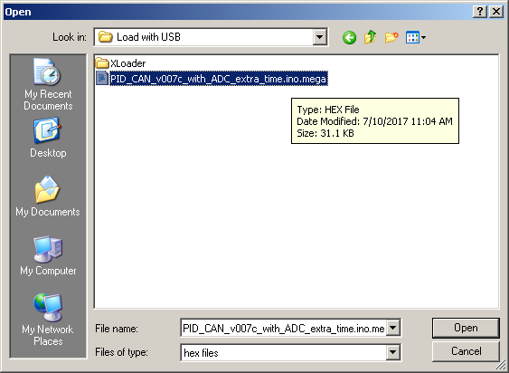

4. Select Mega(ATMEGA2560) as device
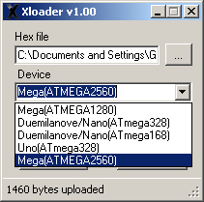
5. Select the COM port your device is on (COM7 in the example. Yours may be different)

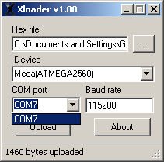

6. Click upload
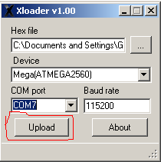

7. Wait until you see the message ## bytes uploaded
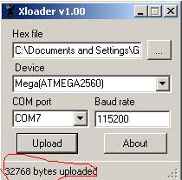

8. Upload has been completed successfully.

